Name:Bestha Sarath kumar

Batch:119

Mail:bskumar2927080@gmail.com

Cell-7702927080

Transit gate way peering in two regions

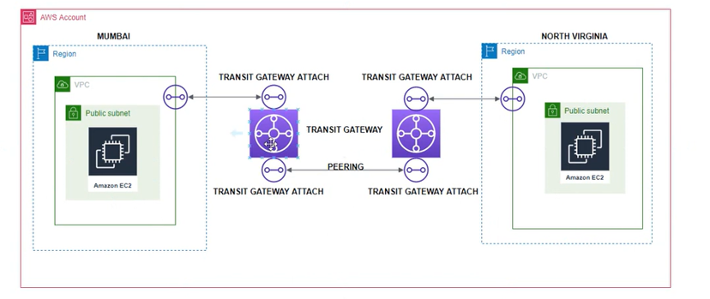

A transit gateway is a **network transit hub** that you can use to interconnect your virtual private clouds (VPCs) and on-premises networks. As your cloud infrastructure expands globally, inter-Region peering connects transit gateways together using the AWS Global Infrastructure.

Procedure:

1.select two different regions.

2.create vpc,subnet,internet gate way,routes in two regions.

3.add routs in route table,subnet association,and attach there vpcs.

3.create transit gate way in two regions.

4.create transit gate attachments in two regions.

5.peering with two diff.regoins transit gate ways.

6.create instances with their vpcs in those regions.

**Virginia California**

**1.Vpc -192.0.0.0/16 1.vpc-193.0.0.0/16**

**2.Subnet 2.subnet**

**3.Internet gate way 3.internet gate way**

**4.Route table,add routes,subnet asso.. 4.routetable,add routes,subnet asso.**

**5.transit gate way 5.transit gate way**

**5.transit gate way attachments 6.transit gate way attachments**

**1.firest region vpc ,subnet,internet gate way,route table**

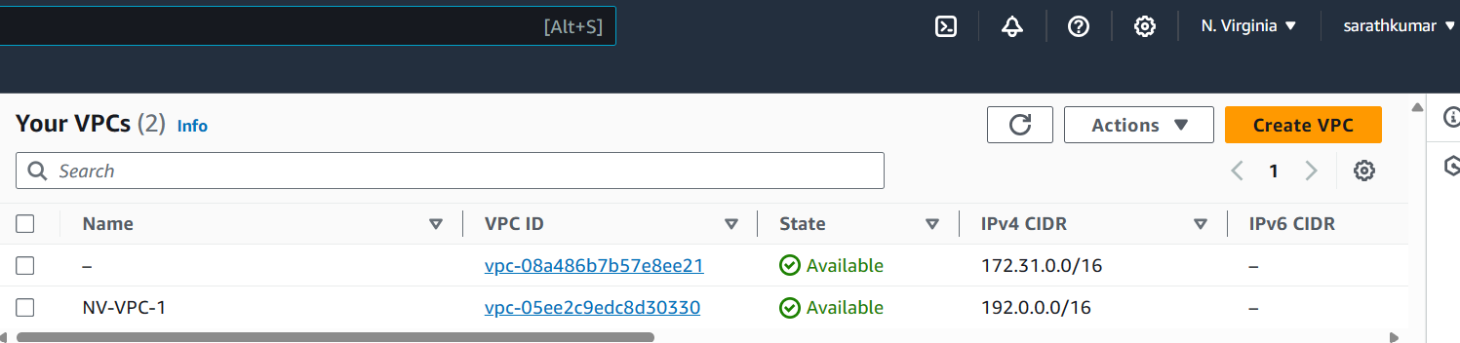

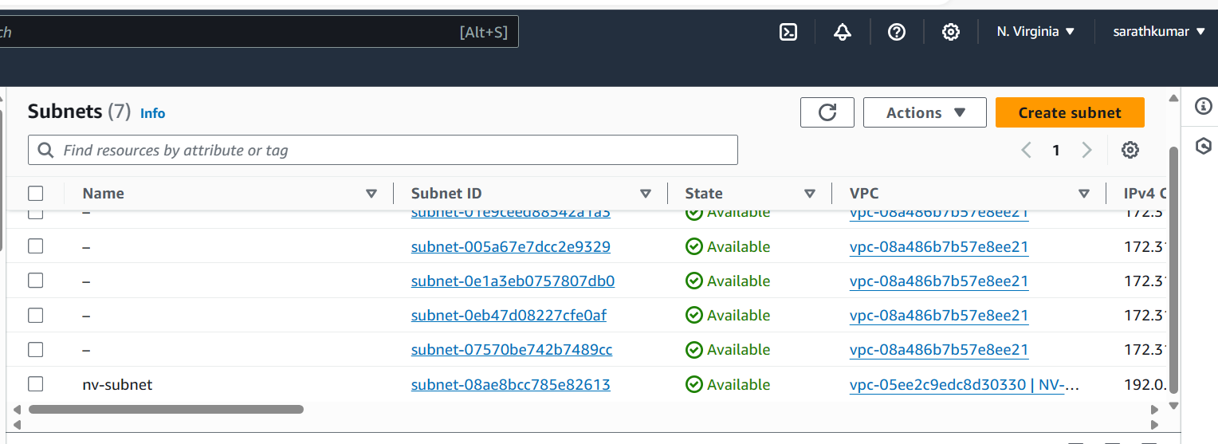

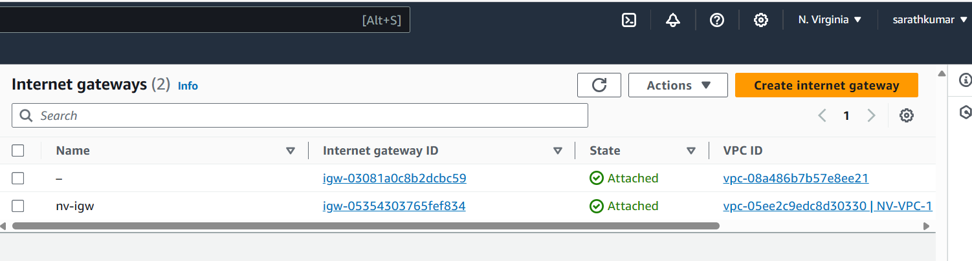

**Attach vpc in internet gate way**

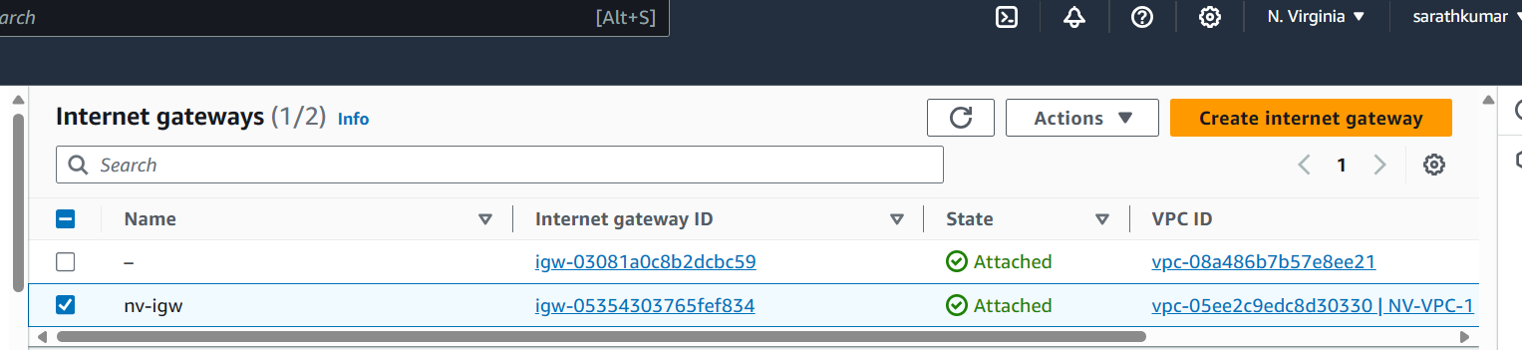

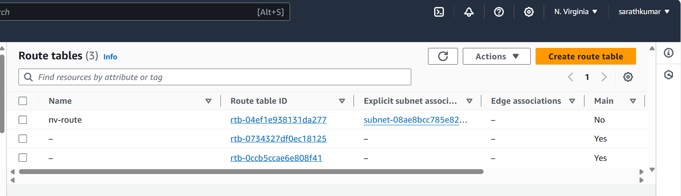

**Edit route table**

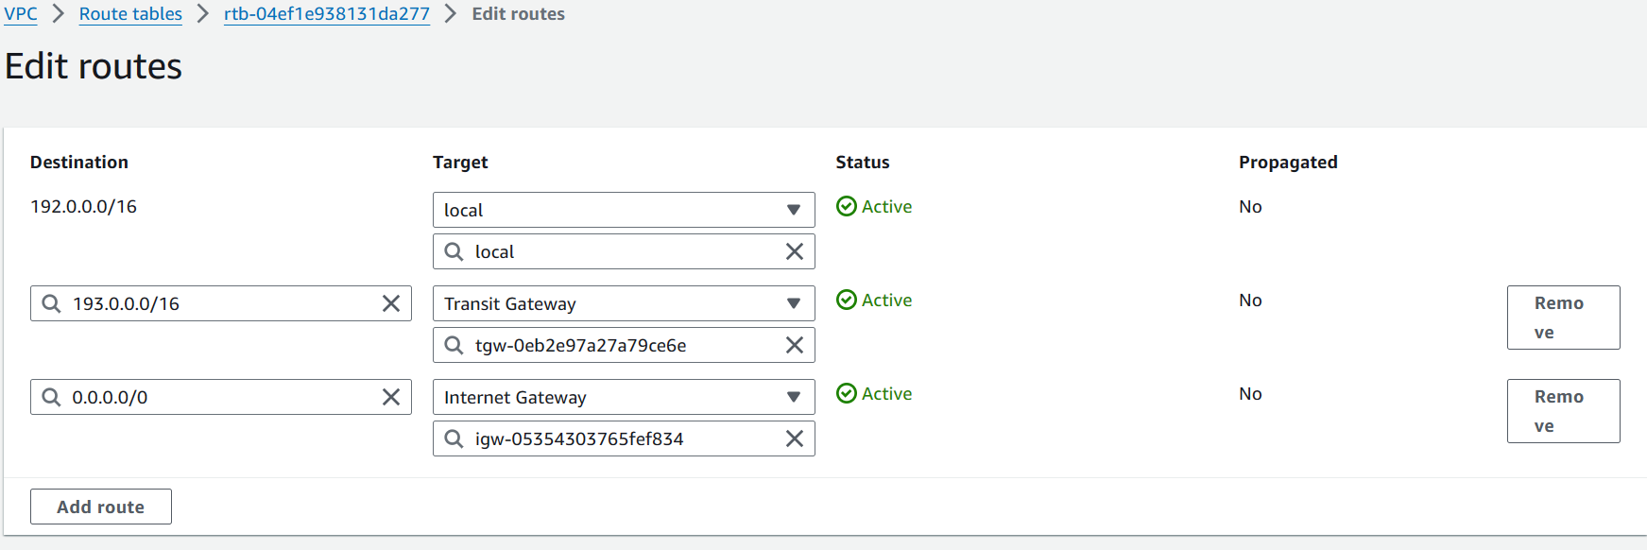

**Subnet association**

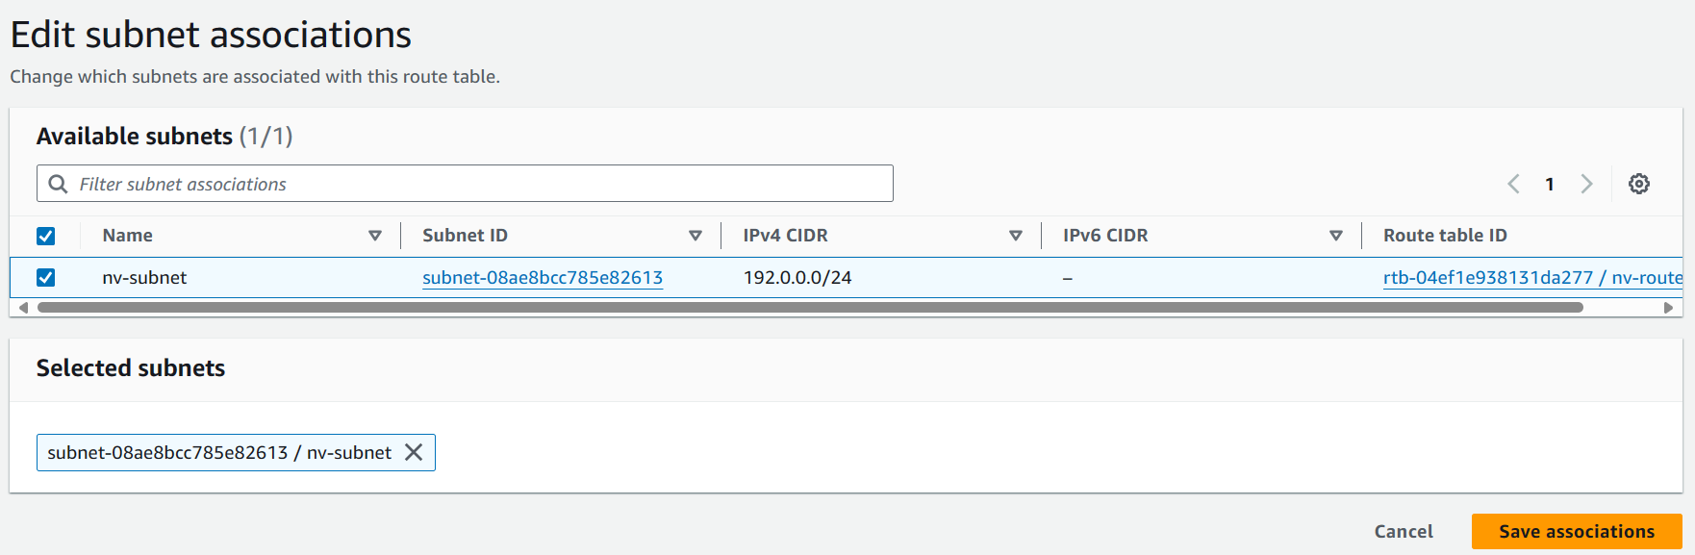

**Create transit gate way**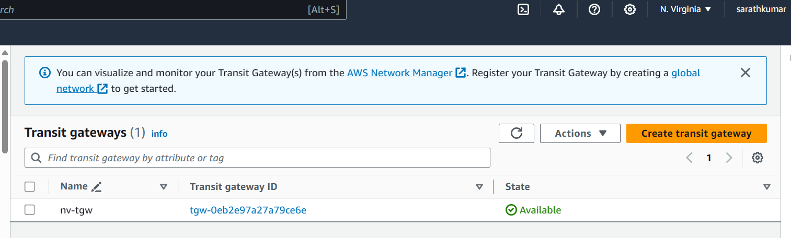

**Transit gate way attachments**

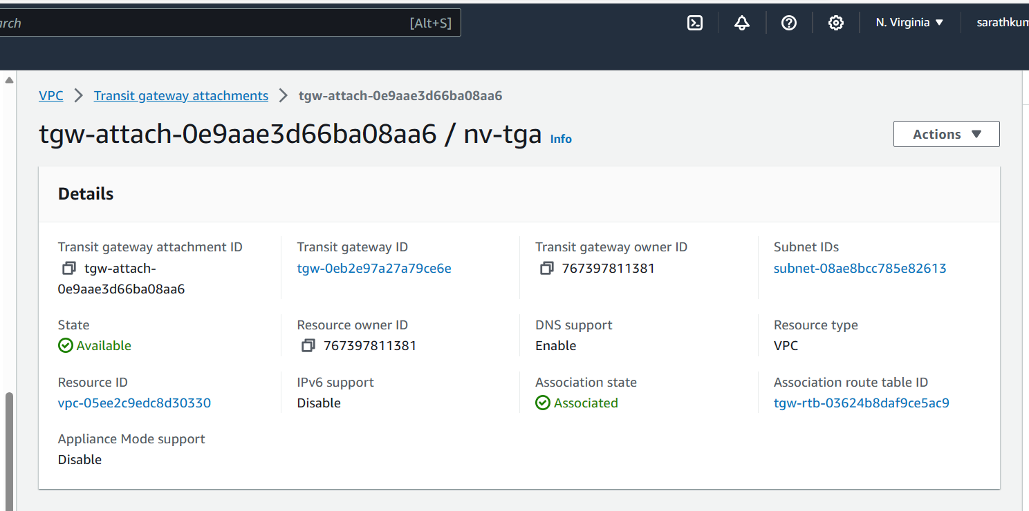

**Create instance in north virginia region**

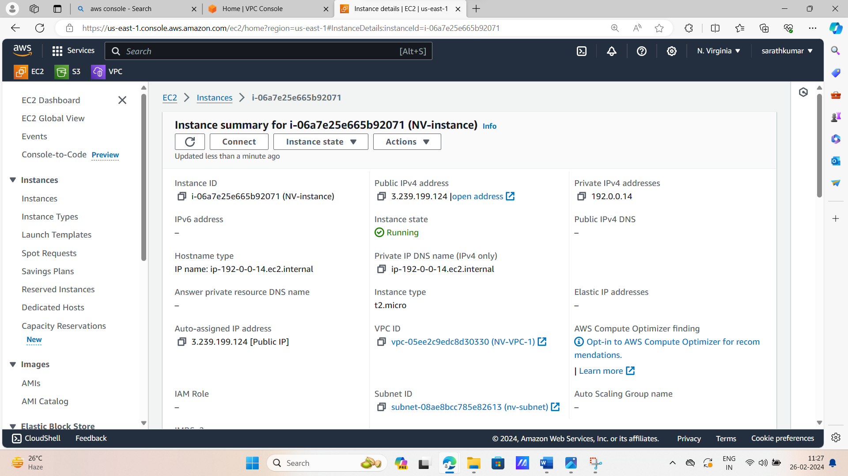

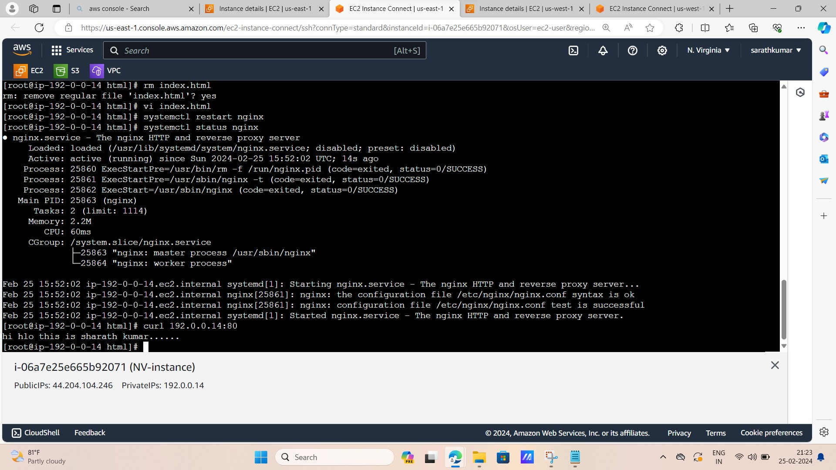**Connect to server,and install nginx,create a file in nginx,restart nginx,status nginx,,,,,,and past curl private ip address-192.0.0.14:80**

**2.another region vpc,subnet,igw,route table,transit gate way,tgw attachment**

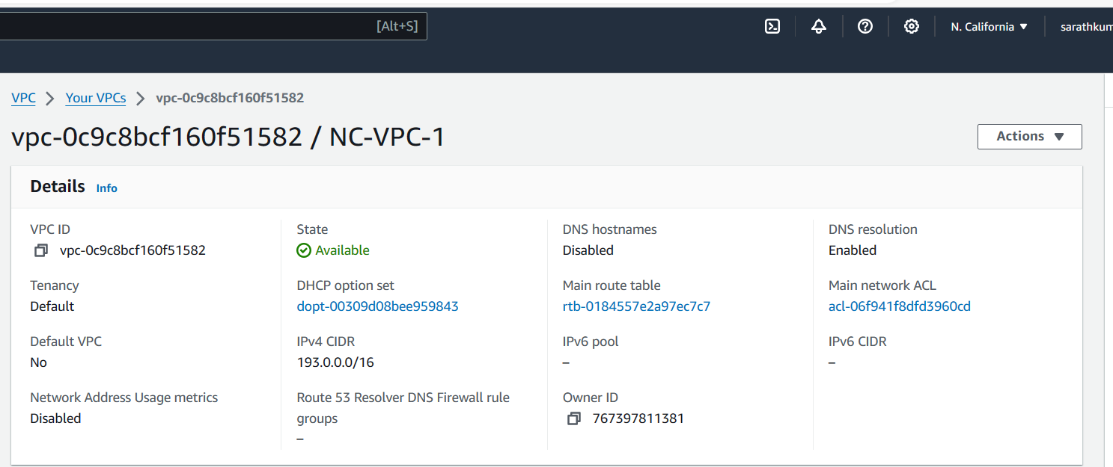

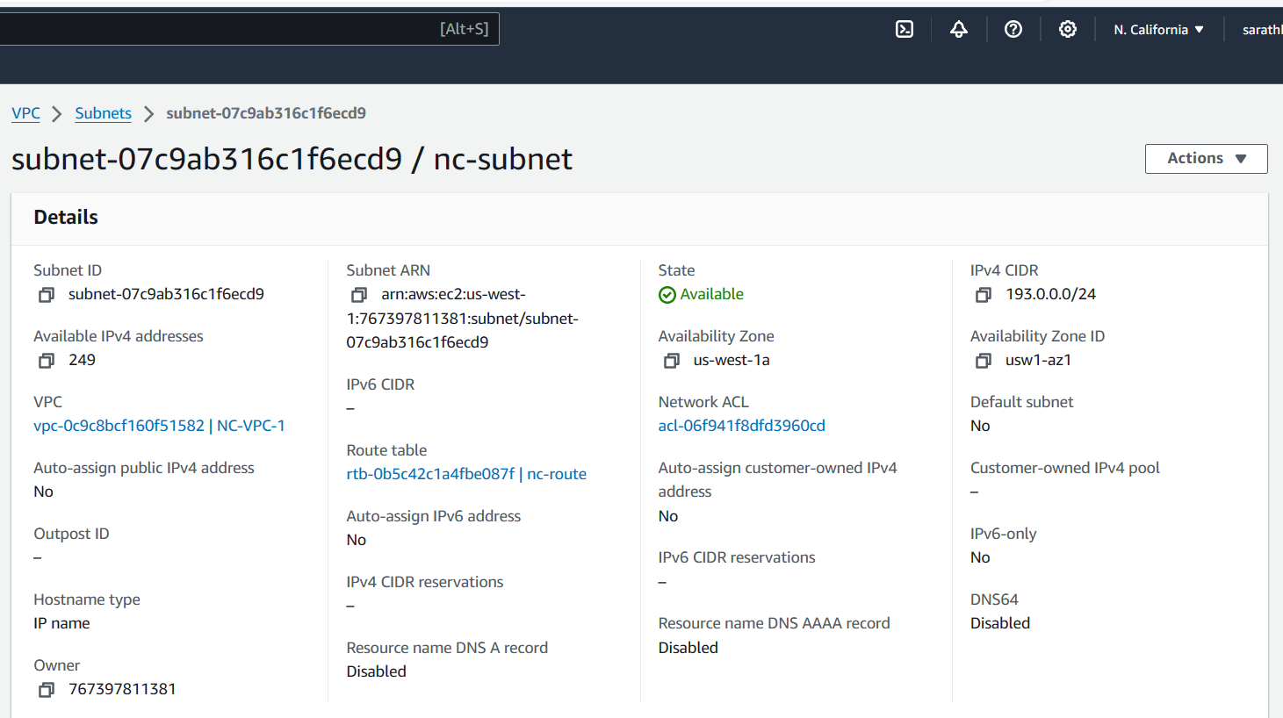

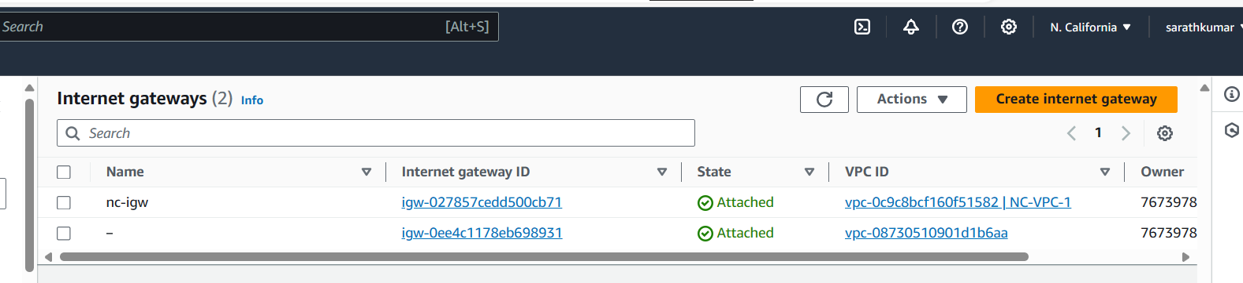

**Attach vpc**

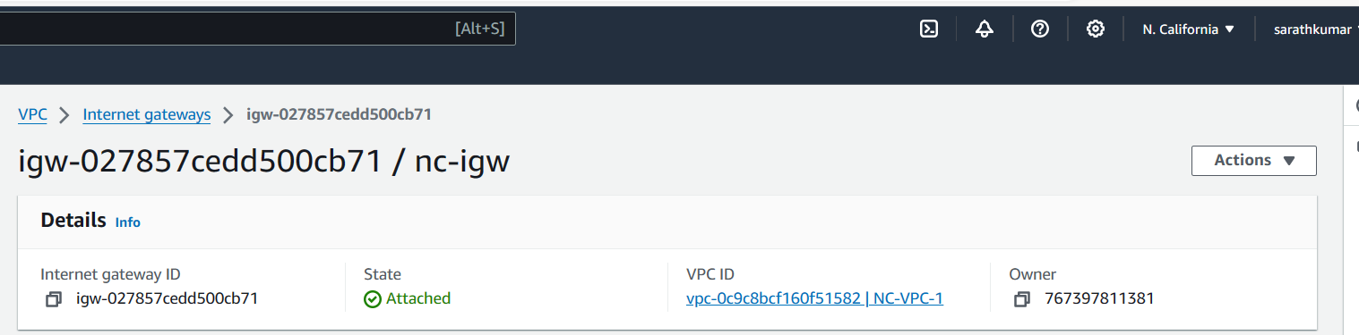

**Transit gate way**

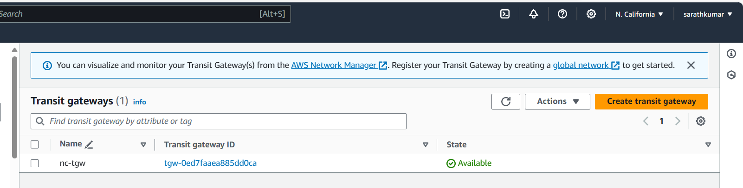

**Transit gate way attachments**

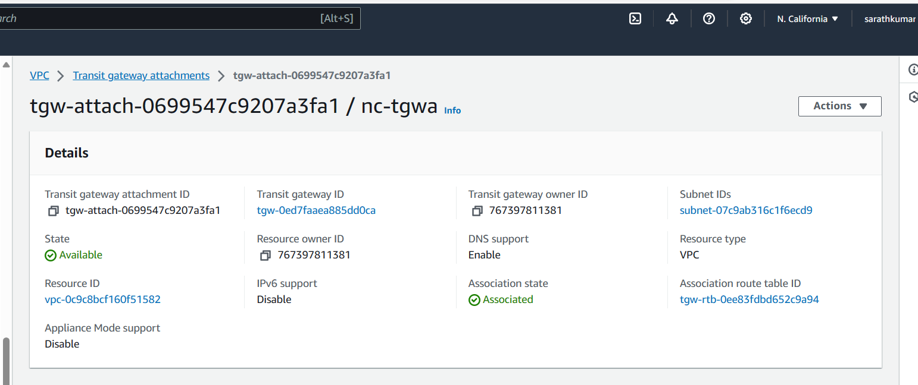

**Create instance in california**

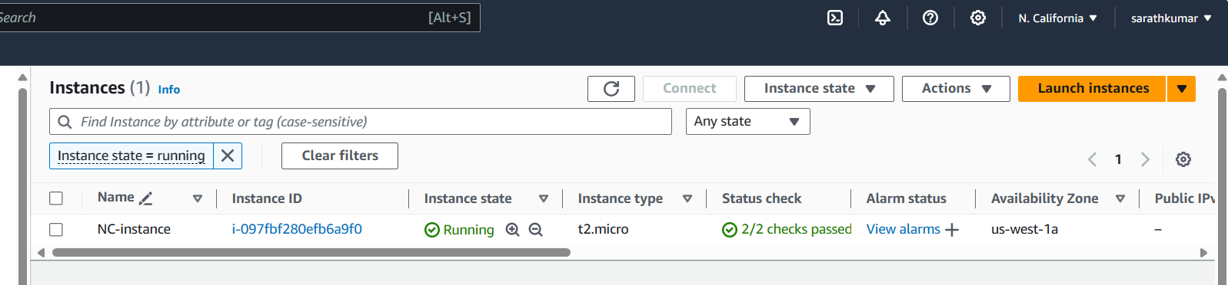

**Lounch instance and try to communicate another region instance…….. its not communicate each other.**

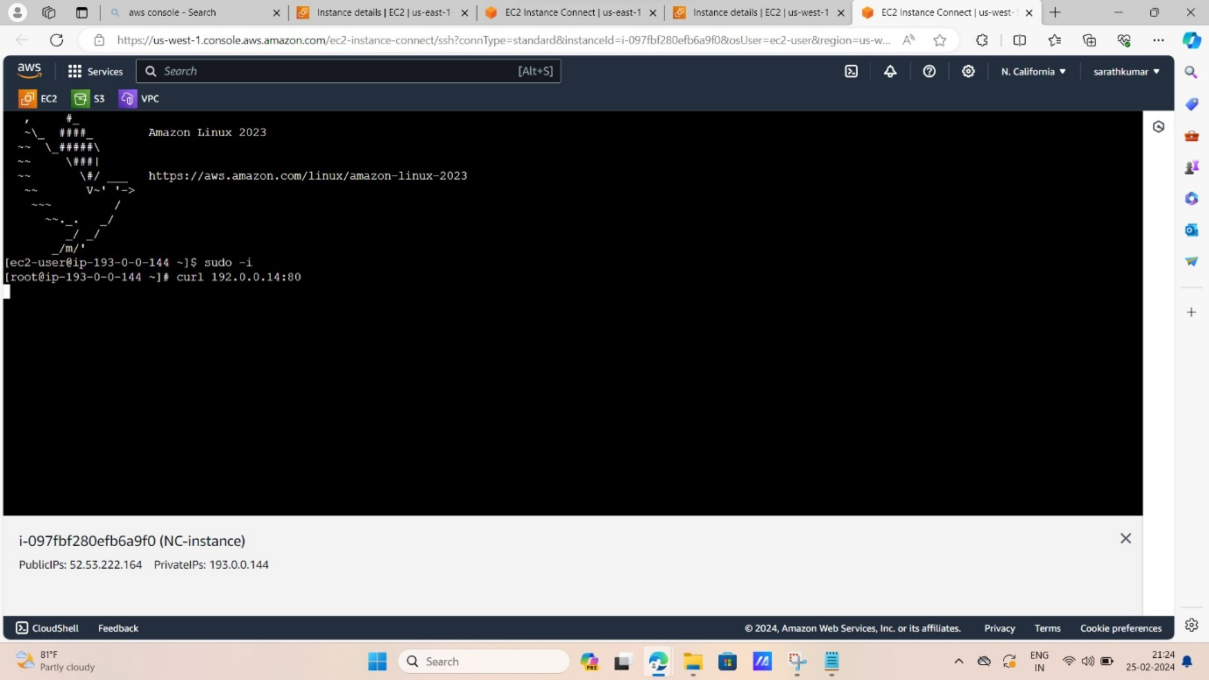

**Now peering with two transit gate ways in two diff regions….**

**Now create transit gate way attachments peering connection in two tgw”s ,and send the accepting request in other region.**

**So now I am send to request varginiya to californiya…..and go to californiya region and accept my request.**

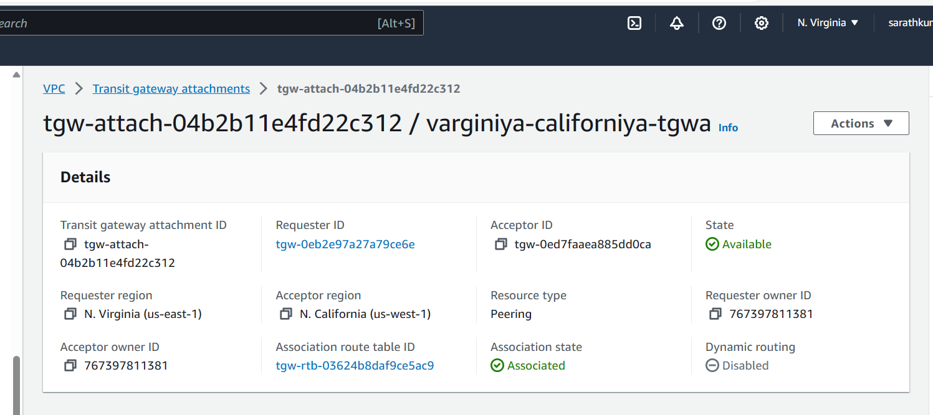

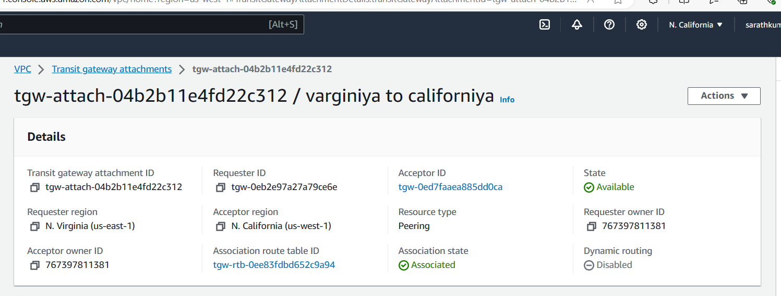

Now you go to transit gate way route table and go to routes and click on create static routes and edit routes….

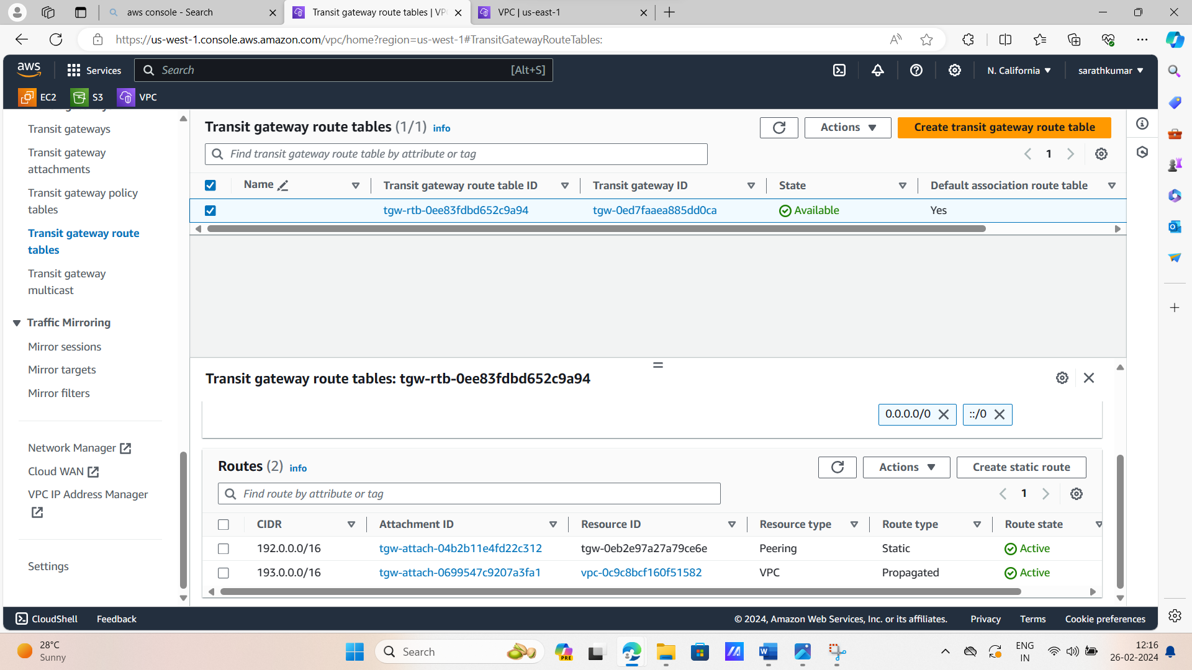

Now go to instance details,click on security,security group,and edit inbonding rules and change the ipv4 adress….and save it.

First region in bonding rules….

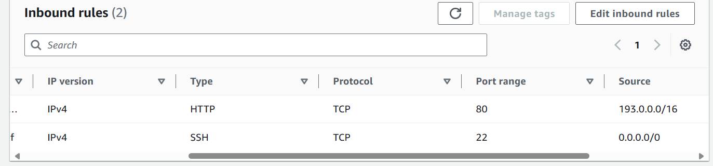

2 region inbonding rules…

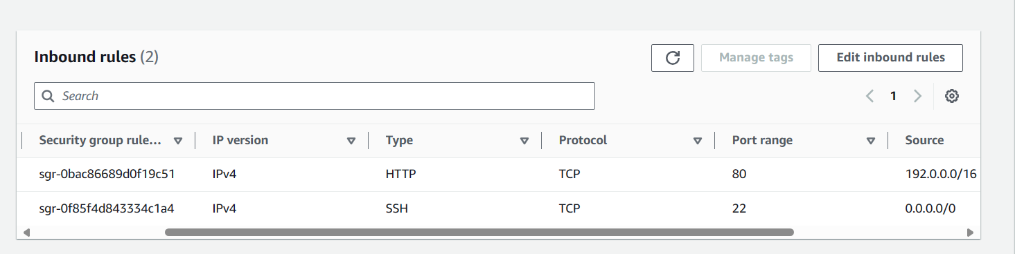

**No go to first lunching server and restart nginx,try to communicate another region server with help to private ip address….** 192.0.0.14:80.

Its successfully communicate to each other regions.

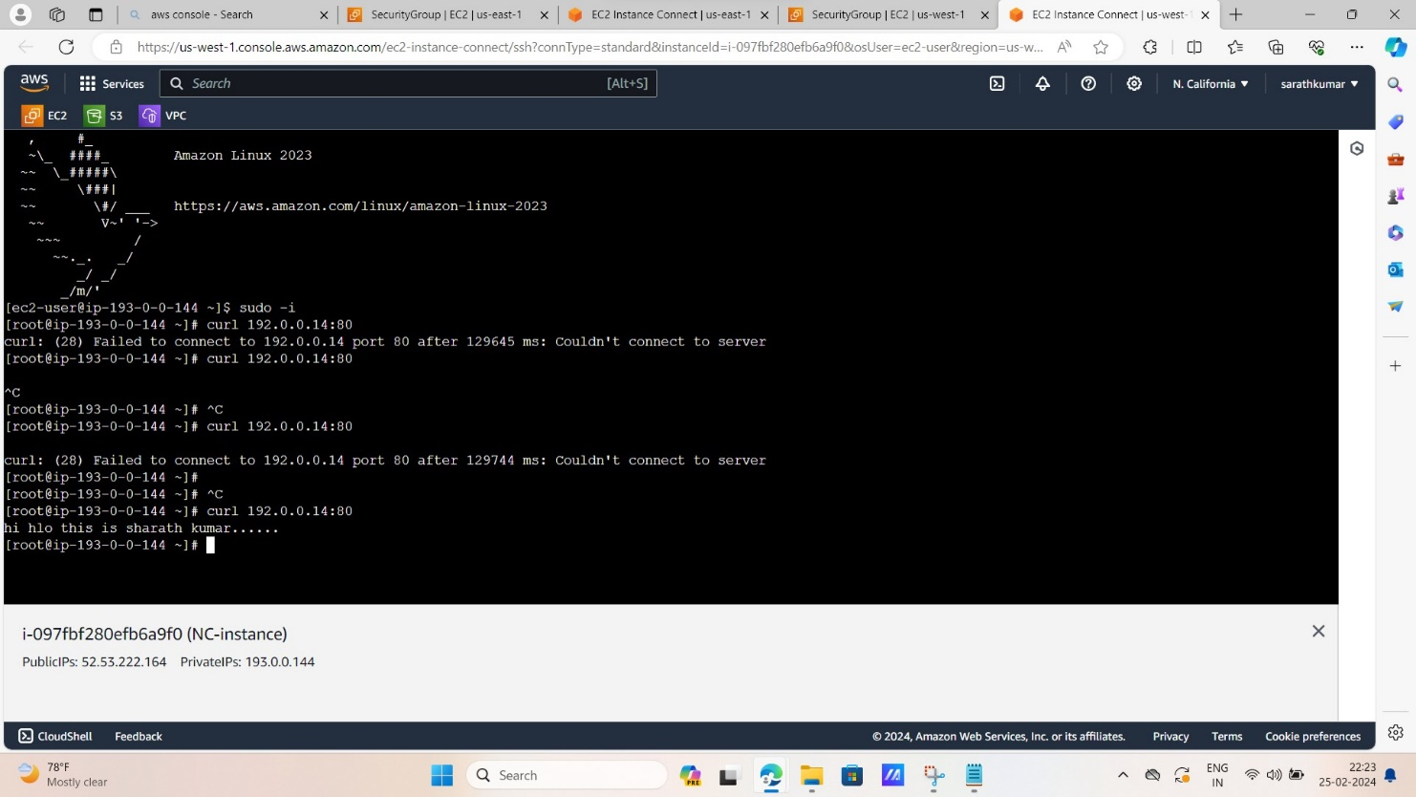

See above picture the two servers are communicate each other in different regions……